A Decision Support System for Assisting in Property Purchase Decisions in Madrid
Réka Szellmann (rs728)
December 22, 2024
University of London - MSc Data Science
DSM100 - Artificial Intelligence
Abstract
This coursework implements a Bayesian network for a real estate decision support system, capturing relationships between key variables such as location, size, condition, and metro access, along with their impact on property price. The document details the conceptual design of the DSS, highlighting possible future improvements. It explains the structure of the Bayesian network and presents all corresponding CPT tables. The implementation is carried out in Python, demonstrating how to model relationships and gather insights using queries on the implemented network.

1. Conceptual design of a DSS
(a) The purpose of the Decision Support System (DSS) is to assist potential buyers in making informed decisions when purchasing a property in Madrid. It uses a Bayesian network¹ to model dependencies and uncertainties related to key property features such as location, price, size, balcony, swimming pool, number of rooms, condition, and closeness to the metro.
(b) Specification for DSS:
- Task: Categorize properties based on key decision factors (location, price, size, balcony, etc.) and provide probabilistic reasoning on the likelihood of a property meeting specific buyer criteria.
- Objectives:
  - Reduce decision-making time by identifying flats that are most likely to meet the user’s preferences
  - Help the user to have realistic expectations
  - Highlight dependencies between key factors like location and price
  - Represent background knowledge in Bayesian network
  - Implement and test the Bayesian network in Python
- Constraints:
  - The system needs to be finished in two weeks, using personal resources
  - The dataset is small and gathered from publicly available advertisements, with probabilities subjectively estimated, which may introduce bias.
  - Lack of domain expertise may limit the accuracy of some assumptions and probabilistic values
  - Start with 8 nodes in the Bayesian network, considering price, location, size, balcony, swimming pool, number of rooms, condition, and metro closeness
  - Additional variables or larger CPTs may lead to increased computational demands
(c) The data required for the DSS is focused on the key features that will be implemented as nodes in the Bayesian network. Initially, I gather insights from data publicly available in property portals², and estimate probabilities manually while keeping the cardinality low:
- Location: represents the distance of properties from Madrid centre (using Sol as a reference point). Categorization:
  - Close (0 - 10km)
  - Far (>10 km)

- Price: the advertised price of properties. Categorization:
  - Affordable (0 - 300k)
  - Expensive (300k <)
- Size: The size of the property, categorized as:
  - Medium (0 - 130m²)
  - Large (130m² <)
- Balcony: Whether a property has a balcony. Categorized as Yes, No
- Swimming Pool: Whether a property has a swimming pool. Categorized as Yes, No
- Number of rooms: How many rooms does the property have. Categorized as One, Two, More
- Condition: Whether the property needs restauration. Categorized as New, Good, Bad
- Metro Access: Whether there is a metro station in 10-minute walking distance. Categorized as Yes, No
Potential risks in the system development
Acquired data might be incorrect or insufficient leading to inaccurate probability estimations. It is also possible that the data is biased; most likely the public prices only reflect how much sellers wish to sell their properties for.
It is difficult to make the CPT tables; even with limited cardinality and nodes, I had to restrict the dependencies on the Price property.
Real estate markets change frequently. To maintain a consistent system, we need to update it regularly to follow market trends.
Possible improvements
The system can be significantly improved by gathering historical data on real estate transactions, and so obtaining real selling prices.
Probabilistic estimates can be refined to reflect real-world trends more accurately. To achieve this, we may collect more data for the different categories, and use:
- Bayesian Estimation
- Frequency-based estimation
E.g. $P\left(Affordable \right| Close,Large)=\frac{Count(Affordable ∩ Close, Large)}{Count(Close, Large)}$
- Machine Learning to estimate conditional probabilities
We can improve the network by adding more nodes (e.g. Garage) and expanding cardinality (e.g. define more price intervals).
We may involve domain specialists to improve the network with additional knowledge. For example, we can add market trends, and additional dependencies.
(d) Stakeholders and users:
- Real estate buyer: the primary users benefitting from the system by receiving tailored recommendations
- Real estate agents: help their clients by providing data-driven insights into property pricing and buyer preferences
- Property sellers and developers: identify desirable features (e.g. balcony) based on user trends and adjust prices accordingly
- Market analysts, Investors: use the system to track trends in property prices, location preferences, and desirable features
(e) It can work as both:
- Standalone system: users give their budget, mark their preferences and receive recommendations based on those inputs
- Integration: the system can be integrated with real-time data sources such as Idealista, allowing it to pull real-time data, and to provide better search results for users.
Additionally, it could be integrated with Google Maps, or different metro maps to provide better location-based recommendations.
2. Development of a simple Bayesian Network
(a) This real estate DSS implements a Bayesian network to assist apartment buyers in Madrid by evaluating the impact of various factors on apartment prices. The following insights were gathered from analysing property advertisements:
- The main influencers of Price are Location, Size, Condition and Metro
  - The CPT for price would become too big if we added all notes
  - It makes sense that the Number of Rooms only indirectly influences the price through Size
  - Balcony and Swimming Pool only slightly influence the Price
- If the Location is Far, the closeness of Metro influences the Price more
- Swimming Pool is more likely if the property is not in the city centre
- Metro is more likely if the property is in the city centre
- Condition is less likely new if the property is in the city centre
- If the Size is Large, it probably has more rooms
(b) Nodes are selected as main considerations when buying a flat. It was also important to be able to filter to them on property-selling websites, or being able to search for them based on approximate addresses:
- Location (Close, Far)
- Price (Affordable, Expensive)
- Size (Medium, Large)
- Balcony (Yes, No)
- Swimming Pool (Yes, No)
- Number of Rooms (One, Two, More)
- Condition (New, Good, Bad)
- Metro (Yes, No)
Links (dependencies) created from the insights:
- Location -> Price
- Size -> Price
- Condition -> Price
- Metro -> Price
- Location -> Swimming Pool
- Location -> Metro
- Location -> Condition
- Size -> Number of Rooms
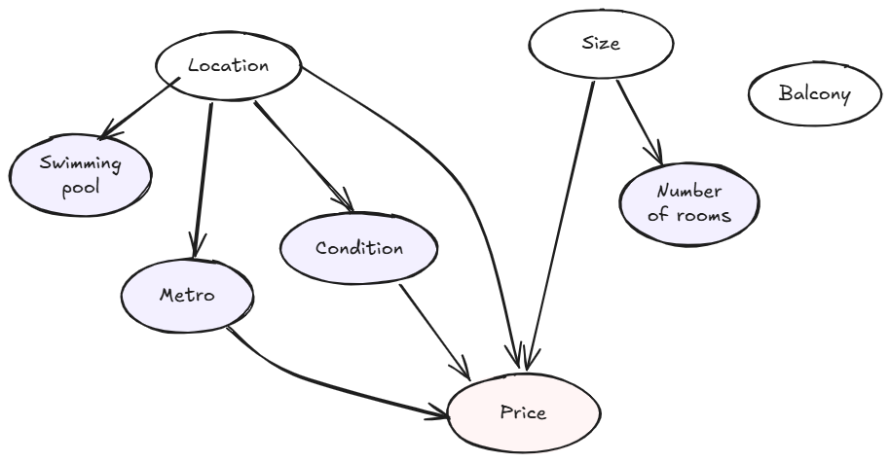
Bayesian network for the simplified Real Estate model
(c) I define the probability tables manually for now based on advertisements available online. It can be improved by reading and analysing data from different sources.³
It is important to ensure that the order defined in the tables remains consistent across all tables and aligns with the Python implementation.
Location CPT (Independent)
Location | Probability
Close | 0.4
Far | 0.6

Size CPT (Independent)
Size | Probability
Large | 0.3
Medium | 0.7

Balcony CPT (Independent)
Balcony | Probability
Yes | 0.5
No | 0.5

Swimming Pool CPT (Dependent on Location)
Location | Swimming Pool (Yes) | Swimming Pool (No)
Close | 0.3 | 0.7
Far | 0.7 | 0.3

Metro CPT (Dependent on Location)
Location | Metro (Yes) | Metro (No)
Close | 0.7 | 0.3
Far | 0.3 | 0.7

Number of Rooms CPT (Dependent on Size)
Size | Number of Rooms (One) | Number of Rooms (Two) | Number of Rooms (More)
Large | 0.2 | 0.3 | 0.5
Medium | 0.5 | 0.3 | 0.2

Condition CPT (Dependent on Location)
Location | Condition (New) | Condition (Good) | Condition (Bad)
Close | 0.2 | 0.5 | 0.3
Far | 0.4 | 0.4 | 0.2

Price CPT (Mostly dependent on Location, Size and Metro)
Condition | Location | Size | Metro | Price (Affordable) | Price (Expensive)
New | Close | Large | Yes | 0.1 | 0.9
New | Close | Large | No | 0.2 | 0.8
New | Close | Medium | Yes | 0.3 | 0.7
New | Close | Medium | No | 0.35 | 0.65
New | Far | Large | Yes | 0.3 | 0.7
New | Far | Large | No | 0.4 | 0.6
New | Far | Medium | Yes | 0.5 | 0.5
New | Far | Medium | No | 0.6 | 0.4
Good | Close | Large | Yes | 0.2 | 0.8
Good | Close | Large | No | 0.3 | 0.7
Good | Close | Medium | Yes | 0.3 | 0.7
Good | Close | Medium | No | 0.4 | 0.6
Good | Far | Large | Yes | 0.3 | 0.7
Good | Far | Large | No | 0.4 | 0.6
Good | Far | Medium | Yes | 0.5 | 0.5
Good | Far | Medium | No | 0.6 | 0.4
Bad | Close | Large | Yes | 0.3 | 0.7
Bad | Close | Large | No | 0.4 | 0.6
Bad | Close | Medium | Yes | 0.5 | 0.5
Bad | Close | Medium | No | 0.6 | 0.4
Bad | Far | Large | Yes | 0.6 | 0.4
Bad | Far | Large | No | 0.7 | 0.3
Bad | Far | Medium | Yes | 0.8 | 0.2
Bad | Far | Medium | No | 0.9 | 0.1

3. Implementation of the Bayesian network in Python
(a) I implemented the Bayesian network based on the materials provided in previous classes. It can be seen in Appendix 1.
(b) The questions formulated, and their answers:
- What is the probable budget needed for medium-size properties that are in the centre, close to a metro station, and has balcony? Does it have a Swimming Pool?
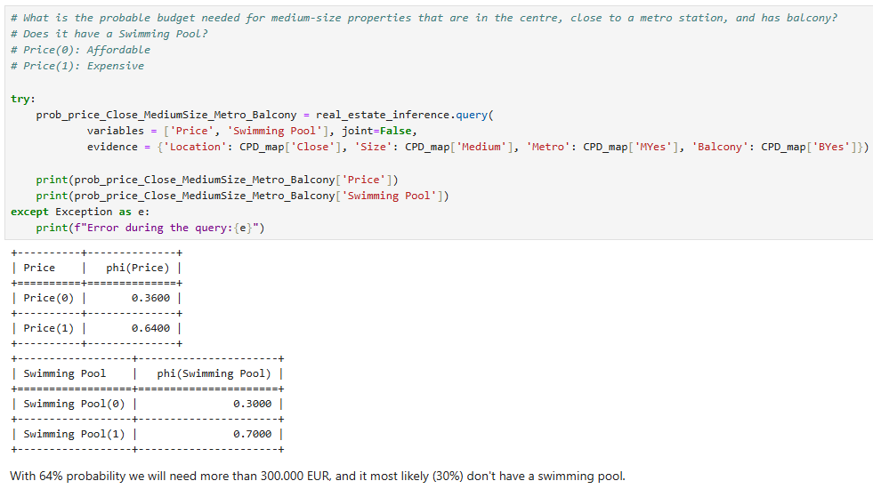
- With 64% probability we will need more than 300.000 EUR, and it most likely do not have a swimming pool (70%)

- How likely is that we find a new large flat for less than 300.000 EUR in the city centre which has 4 rooms?
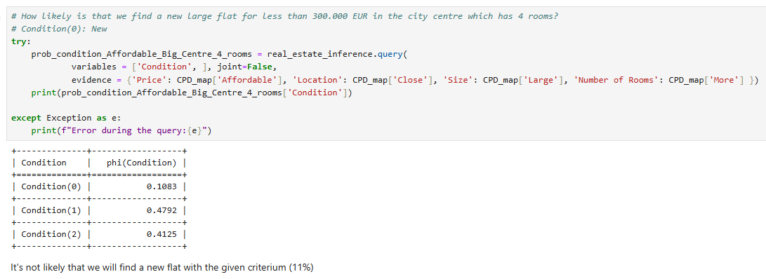
- It is not likely that we will find a new flat with the given criterium (11%)

- How many rooms may a flat have which is in the city centre, affordable, and not in bad condition?
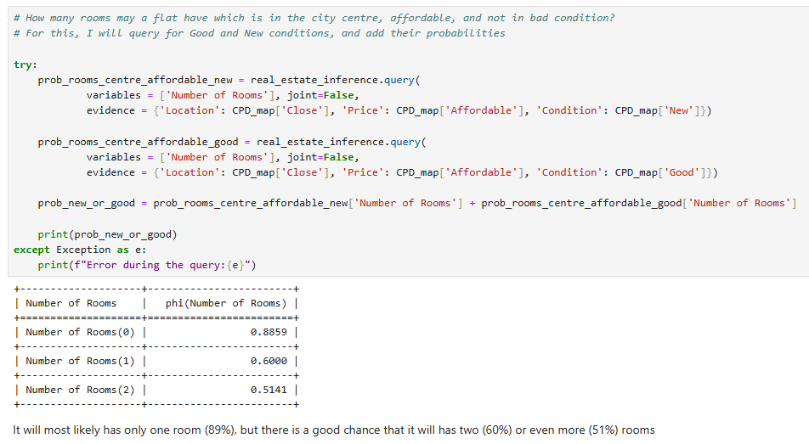
- It will most likely have only one room (89%), but there is a good chance that it will have two (60%) or even more (51%) rooms

Bonus Task. Causal inference with Bayesian networks
I tested three variables for Price:
- Metro has only a minimal effect (close to 50%). It might be because it is not a filtering option in the advertisements used to gather data. As a result, the current dataset does not account for Metro's impact sufficiently. Improved data collection and refined probability estimation could reveal a more significant effect.
- Location being Close to the centre has a moderate effect, it shifts towards Expensive (66%)
- Condition being Bad also has a moderate effect shifting the price towards 67%
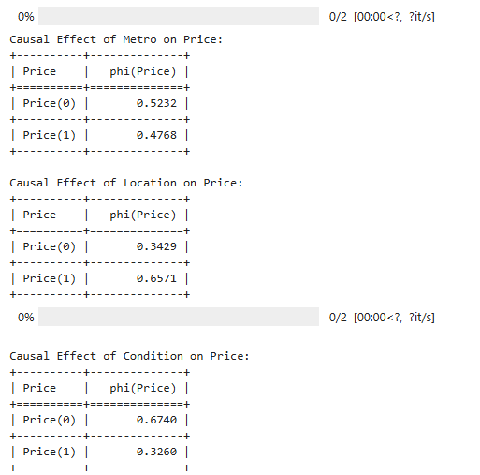
I checked probabilities for price, and how it changes after I set location to Far: it did not have a big effect (around 10%), but changed the odds: 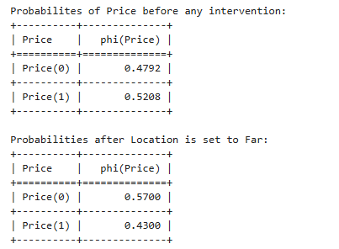
I also checked Price if the Condition is set to Bad: it had a slightly bigger effect favouring the lower prices (67%).
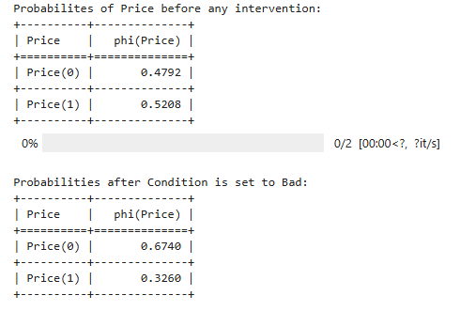
Conclusion
The development and analysis of this Bayesian network-based DSS demonstrate its potential to assist in real estate decision-making. The system effectively captures the relationships between key variables, such as Location, Size, Condition, and Metro, and their impact on property Prices. The network's conceptual design, CPT tables, and Python implementation were developed and validated.
Additionally, causal inference was applied to estimate the influence of individual factors, revealing that Location and Condition has a bigger effect to price, while others like Metro only had a minimal impact.
Overall, this task highlights the practical application of Bayesian networks for decision support and causal analysis in complex domains.
Word Count: 1831
References
¹: Bayesian network is a directed graph in which each node is annotated with quantitative probability information.
Russell, Stuart J., Peter Norvig, and Ming-Wei Chang. , 'Artificial Intelligence a Modern Approach', Anonymous Translator (Fourth, Global;Global; edn, Harlow, England, Pearson, 2022;2021;) Chapter 13.1
²: Idealista (2024). Apartment Listings. Retrieved from https://www.idealista.com
Fotocasa (2024). Property Listings. Retrieved from https://www.fotocasa.es
³: Examples for additional real estate data:
- Official data: registradores.org, https://www.transportes.gob.es/, https://datos.madrid.es/portal/site/egob
- Agency reports: https://www.knightfrank.com/publications/madrid-insight-2023-9997.aspx

